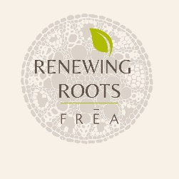
Renewing Roots | Professional Referral Form

Renewing Roots offers free, confidential support for former residents of Ireland's Mother and Baby and County Home institutions now living in the North of England.
Thank you for making a referral. By completing this form, you confirm that consent has been given for you to share the information enclosed.
Please email to: renewingroots@frea.org.uk

Person making referral:
Contact Information

Name
Name of organisation
Date referral made

Person being referred:
Contact Information

Name
Address

Postcode
Telephone
Mobile
Email
Date of birth
Institutional Information

Name of Mother and Baby Home or County Home Institution resided in? (if known)
Date entered (if known) | month and year
Date left (if known) | month and year

Benefits received (please answer yes or no)

Universal Credit
Pension Credit
Housing Benefit
Council Tax Support
Employment Support Allowance
Job Seekers Allowance
Income Support
Other (please specify)
Support Requested (Please answer yes or no to each of our services)
Access birth and early life records
Trace family members
Access the Payment Scheme & Healthcare Payment
Access specialist counselling
Support connecting to local services and community events. These include welfare entitlements, health care and social and cultural groups.

